* **Boilerplate code** is repetitive, standard code that is used across multiple parts of a program with little to no variation. It often includes setup and structure code such as import statements, class definitions, and function signatures, which are necessary but do not contribute to the core functionality of the program..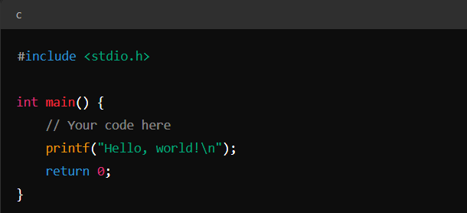
* **Amperand** symbol is &
* Manually you can execute c/c++ program by “ gcc codefilename” then for executing exe machine code file a… type “./a”